**Project Name: Public Transportation Optimization**

**Phase 5**

**Project Overview:** Project Name: IoT-Based Public Transportation Optimization

**Objectives:**

1. Develop a real-time transit information system to improve public transportation efficiency and user experience.
2. Deploy IoT sensors on vehicles and at transit stations to collect data.
3. Develop a platform to process and display real-time transit data.
4. Implement code for sensor data transmission, data processing, and user interface.

**IoT Sensor Deployment:**

* **Vehicle Sensors:**
  + GPS sensors to track the location of buses/trains.
  + Environmental sensors for temperature and humidity.
  + Passenger counters to monitor occupancy.
  + Connectivity to the vehicle's onboard computer for engine and maintenance data.
* **Station Sensors:**
  + RFID/NFC sensors for tracking passengers' entry and exit.
  + Environmental sensors for monitoring weather conditions.
  + CCTV cameras for security and monitoring.

**Platform Development:**

* **Data Ingestion:**
  + Set up a cloud-based data ingestion system to collect data from IoT sensors.
  + Use MQTT or HTTP protocols for sensor data transmission.
  + Store the data in a database (e.g., PostgreSQL, MongoDB).
* **Data Processing:**
  + Develop real-time data processing pipelines to clean and transform sensor data.
  + Apply machine learning algorithms for predicting arrival times and optimizing routes.
  + Implement real-time analytics for passenger counting and occupancy monitoring.

**Architectural Diagram: IoT Transit Information System**

**Components:**

1. **Vehicle Sensors:**
   * GPS, Environmental, Passenger Counters.
   * These sensors are installed on public transit vehicles (buses, trains, etc.) and collect data like location, environmental conditions, and passenger count.
2. **Data Ingestion & Processing:**
   * This component handles the collection, processing, and storage of sensor data.
   * It uses MQTT/HTTP protocols to receive data from sensors.
   * Data is ingested, cleaned, and stored in a database.
   * Real-time data processing algorithms may be applied for predictions and route optimizations.
3. **User Interface (Web Dashboard & Mobile Apps):**
   * The user interface component allows passengers and transit operators to interact with the system.
   * Web Dashboard: A web-based interface for transit operators to monitor the system's performance.
   * Mobile Apps: Android and iOS apps for passengers to track vehicle locations and plan journeys.

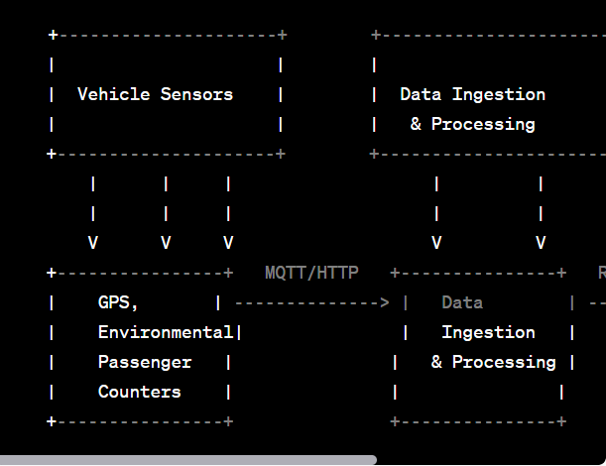

**Real-time transit information system can improve public transportation and passenger experience**

1. **Accurate Arrival and Departure Information:**
   * Passengers can access real-time information about when the next vehicle (bus, train, tram, etc.) will arrive or depart at a specific stop or station.
   * This reduces uncertainty and minimizes waiting times, making public transportation more convenient.
2. **Optimized Route Planning:**
   * Passengers can use the system to plan their routes more efficiently. It can provide suggestions for the fastest or most convenient routes to their destinations.
   * This encourages the use of public transportation by making it a competitive option against private vehicles.
3. **Crowd Management:**
   * Real-time data on passenger occupancy and availability of seats can help passengers make informed decisions about which vehicles to board.
   * Transit operators can manage crowd density by adjusting routes or schedules during peak hours.
4. **Safety and Security:**
   * Integrated CCTV cameras and panic buttons in transit stations and vehicles can improve passenger safety.

**Instructions on how to replicate the project, deploy IoT sensors**

**1. IoT Sensor Deployment:**

* Choose the IoT sensors and hardware that best suit your project's needs.
* Write code to interact with the sensors and gather data. Here's an example for a simple environmental sensor (using Python libraries like **Adafruit_CircuitPython_BME280**):

import board

import busio

import adafruit_bme280

i2c = busio.I2C(board.SCL, board.SDA)

bme280 = adafruit_bme280.Adafruit_BME280_I2C(i2c)

temperature = bme280.temperature

humidity = bme280.humidity

**2. Data Ingestion and Processing:**

* Set up a cloud-based database to store the data. You might use a service like AWS or Azure.
* Use Python to create a script for data ingestion:

import requests

data = {

"temperature": temperature,

"humidity": humidity

}

response = requests.post("https://your-data-ingestion-api-endpoint.com", json=data)

**3. User Interface Development:**

* Choose a web framework (e.g., Django, Flask) to build the user interface. Here's a simple Flask example for a web page displaying temperature and humidity:

from flask import Flask, render_template

app = Flask(__name)

@app.route('/')

def index():

return render_template('index.html', temperature=temperature, humidity=humidity)

if __name__ == '__main__':

app.run()

**4. Integration:**

* Create RESTful APIs in your Python web framework to serve data to the user interface.
* Here's an example of a Flask route:

from flask import Flask, jsonify

@app.route('/api/data', methods=['GET'])

def get_data():

data = {

"temperature": temperature,

"humidity": humidity

}

return jsonify(data)

* In the user interface (JavaScript), you can make AJAX requests to these APIs to fetch and display real-time data.

**5. Testing, Deployment, Documentation, and Maintenance:**

* Testing: Write test cases for your Python code using testing libraries like **pytest**.
* Deployment: Deploy your application to a web server or cloud platform.
* Documentation: Document your project thoroughly for future reference.
* Maintenance: Regularly update and maintain your system.